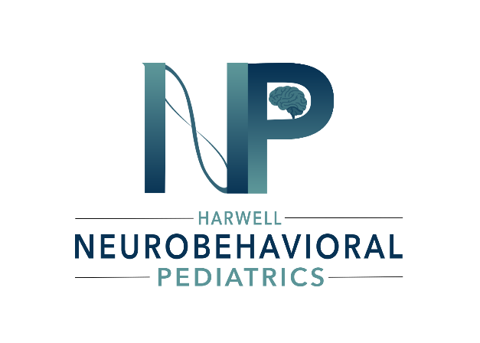

Harwell Neurobehavioral Pediatrics LLC
1708 Mockingbird Lane
Lakeland, FL 33801
(Located inside Blue Sky Pediatrics)
Phone: (863)867-1886
Fax: (863)403-2164
Email: office@harwellneurobehavioralpediatrics.com

Fees and Payment Terms
- Comprehensive Neurobehavioral Assessment and Diagnosis which includes 2-3 virtual visits-$800.00
*Introductory Rate-$600.00 (March 2026-July 2026)
- Additional Autism Spectrum Disorder Assessment (ADOS-2) which includes one on-site visit-$400.00
*Introductory Rate-$300.00 (March 2026-July 2026)
- Cognitive and Academic Screening (Ages 6 and Up) which includes one on-site visit for ages six and up-$400.00-$600.00
*Introductory Rate-$300.00-$450.00 (March 2026-July 2026)
(Cognitive Screening) $300.00
(Academic Screening) $300.00
(Cognitive AND Academic Screening) $450.00

- As this is a fee-for-service practice, you are responsible for payment of all charges for services provided. We accept the following payment methods:
  - Major credit/debit cards (Visa, Mastercard, American Express, Discover)
  - HSA/FSA cards
  - Electronic payments via our secure patient portal
- Payment is due by 3pm the day before the scheduled appointment, or the appointment will be cancelled or rescheduled.
- For your convenience, we offer the option to keep a credit or debit card on file. By providing this information, and accepting these terms, you authorize Harwell Neurobehavioral Pediatrics to charge your card for
  - Any outstanding balance
  - Services rendered at the time of the visit.
  - No-show fees (if applicable)
- We use a secure, HIPAA-compliant system to store payment information. You may request removal of your card at any time.
Services Provided
  - Comprehensive Neurobehavioral Assessment and Diagnosis
VIRTUAL appointments with our provider, including a thorough review of birth, developmental, medical, academic, family history, and areas of concern. Comprehensive behavior rating scales for parent, teacher, and self to evaluate for a broad range of behavioral, emotional, social, and academic issues. Follow up VIRTUAL appointment(s) to review results of all evaluations and provide diagnosis, personalized recommendations, and referral if needed. The child should be available for the initial intake appointment.
  - Autism Spectrum Disorder Assessment (ADOS-2)
If there's a concern about autism, we offer the ADOS-2-the gold standard, research-backed assessment for autism spectrum disorder. This tool is completed alongside our initial neurobehavioral assessment to provide a thorough and accurate understanding of your child's unique strengths and needs. ​
The ADOS-2 can also be administered as a stand-alone evaluation. We would provide the result to you or your child's provider who can use it to supplement any existing assessments.
The ADOS-2 is an ON-SITE assessment in our private, sensory friendly space designed to help your child feel comfortable and at ease.
  - Cognitive and Academic Screening (Ages 6 and Up)
If there's a concern about learning difficulties, our Cognitive and Academic screening provides valuable insights into your child's cognitive strengths and academic skill levels. This tool is completed alongside our initial neurobehavioral assessment-seamlessly integrated with our full evaluation.
The screening can also be administered as a stand-alone evaluation. We would provide the result to you or your child's provider who can use it to supplement any existing assessments.
This is an ONSITE assessment in a private sensory friendly space designed to help your child feel comfortable and at ease.​
Insurance and Medicaid Policy
- The Practice does not participate in any insurance plans or third-party payors.
- Medicaid patients are welcome, but Medicaid cannot be billed for services under this Agreement.
Communication Policy
- Electronic communications (email, text, video chat, etc.) are offered for convenience but cannot be absolutely guaranteed secure.
- You may opt out of any communication method.
- The secure patient portal is the preferred method for sharing sensitive information.
- Email and text are not appropriate for emergencies; call 911 or visit an emergency facility in urgent situations.
Telehealth
- Telehealth (virtual visits) will be utilized with your consent.
- Risks include technological limitations, confidentiality breaches, and inability to conduct full physical exams.
- All telehealth sessions use secure, encrypted platforms.

Harwell Neurobehavioral Pediatrics provides developmental and behavioral health services in accordance with a pediatric primary care scope.
Conditions Within Scope:
- Attention-Deficit/Hyperactivity Disorder (ADHD)
- Oppositional Defiant Disorder (ODD)
- Conduct Disorder
- Anxiety Disorders (including Generalized Anxiety Disorder, Social Anxiety Disorder, Separation Anxiety Disorder)
- Depressive Disorders (mild to moderate Major Depressive Disorder, Persistent Depressive Disorder)
- Autism Spectrum Disorder (assessment, diagnosis, and coordination of care)
- Learning Disorders (screening and referral coordination)
- Simple Tic Disorders
- Other common pediatric developmental and behavioral conditions

Patients will be referred to appropriate specialists for conditions outside the defined scope of practice, including but not limited to:
- Severe depression
- Bipolar disorder
- Psychotic disorders (schizophrenia, schizoaffective disorder)
- Severe anxiety disorders requiring intensive treatment.
- Eating disorders
- Substance use disorders requiring specialized treatment.
- Self-harm or suicidal ideation requiring intensive intervention.
- Complex trauma or PTSD requiring specialized therapy.
- Severe behavioral disorders not responsive to initial interventions
- Any condition requiring inpatient psychiatric hospitalization.
- Medical conditions requiring subspecialty evaluation.

Referrals may be made to child and adolescent psychiatrists, developmental-behavioral pediatricians, clinical psychologists, or other appropriate specialists.

